**Year 12 ATAR Chemistry**

Task 8: Organic Chemistry Test

Weighting: 5% of Year Grade

NAME: ______________________________

|  |  |  |  |
| --- | --- | --- | --- |
| **SECTION** | **NUMBER OF QUESTIONS** | **AVAILABLE MARKS** | **MARK** |
| Multiple Choice | 10 | 10 |  |
| Short Answer | 5 | 31 |  |
| Extended Response | 1 | 13 |  |

**Instructions:**

* You will be given 55 minutes’ working time to complete the test.
* Multiple choice answers should be given on the answer sheet provided.
* Short response questions should be written in the spaces provided.
* Any calculations must show FULL WORKING and be stated to the appropriate number of significant figures or marks will be deducted.
* Use BLACK or BLUE pen only.
* Scientific calculators are permitted for this test.
* A Chemistry Data Sheet will be provided with this test.

**SECTION A: MULTIPLE CHOICE SECTION (10 marks)**

INSTRUCTIONS

**Question 1**

Which of the following statements does not relate to an explanation of why ethanol and water are miscible (i.e., form a homogenous mixture)?

(a) The non-polar region on an ethanol molecule is very small

(b) Ethanol molecules can form hydrogen bonds

(c) The intermolecular forces present in water are stronger than those in ethanol

(d) Ethanol molecules are highly polar

**Question 2**

Examine this section of the structure of an addition polymer.

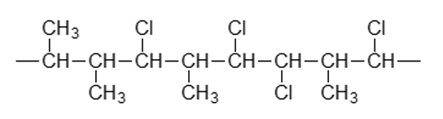

Which of the following is the monomer for this substance?

(a) CH3CHCHCl

(b) CH3CHCHCH2Cl

(c) CH3CClCHCH3

(d) CH3CHCHCHCHCl

**Questions 3 and 4 relate to the four isomers of C5H11OH shown below.**

|  |  |  |  |
| --- | --- | --- | --- |
|  |  |  |  |

**Question 3**

Which of the isomers would not react when mixed with acidified sodium permanganate solution?

(a) A

(b) B

(c) C

(d) D

**Question 4**

Which of the following is not a possible organic product resulting from oxidation of the isomers above?

(a) 3-methylbutanoic acid

(b) 2-methylbutanoic acid

(c) 3-methylbutanone

(d) 2-methylbutanone

**Question 5**

Which one of the following compounds has the highest solubility in water?

(a) butane

(b) butan–1–ol

(c) butanal

(d) but–1–ene

**Question 6**

Which of the following molecules has not been given the correct IUPAC name?

|  |  |
| --- | --- |
| (a) 4,5-dibromo-pentanamine | (b) propyl methanoate |
| (c) 2-chloro-3-methylhexanal | (d) 3-ethyl-4-methyl-heptane |

**Question 7**

Which of the following correctly shows a common use of each plastic?

*polyethene polytetrafluoroethylene polystyrene polyvinylchloride*

(a) Plastic bags non-stick surfaces foam cups water pipes

(b) Non-stick surfaces plastic bags water pipes foam cups

(c) Non-stick surfaces foam cups plastic bags water pipes

(d) Water pipes non-stick surfaces foam cups plastic bags

**Question 8**

The number of carbon-to-carbon double bonds (C=C) in a molecule can be identified by reacting the molecule with hydrogen gas, H2. The type of reaction involved is an addition reaction.

If 0.065 mol of an unknown organic molecule becomes fully saturated after reacting with 0.263 g of H2, how many carbon-to-carbon double bonds were present?

(a) 1

(b) 2

(c) 3

(d) 4

**Question 9**

A compound has the following skeletal formula

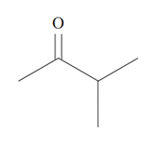

The molar mass of the compound is:

(a) 71 gmol-1

(b) 74 gmol-1

(c) 85 gmol-1

(d) 86 gmol-1

**Question 10**

In which one of the following structures does cis-trans isomerism exist?

(a) CH2CHCH2Cl

(b) CH3CHCHCH2Cl

(c) (CH3)2CCHCH3

(d) ClCH2CH2Cl

**SECTION B: SHORT ANSWER SECTION (31 marks)**

**Question 11**

PHBV is a biodegradable, non-toxic plastic that is produced naturally by some types of bacteria. A fragment of the PHBV polymer is shown below.

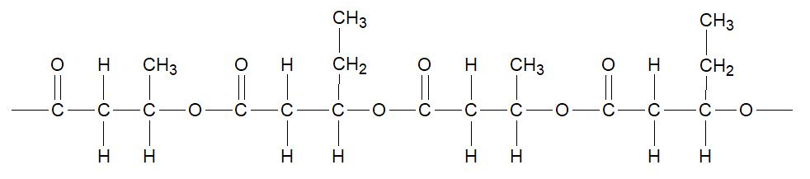

(a) Draw the two (2) monomers from which this copolymer is formed and give the IUPAC name for each.

[4 marks]

|  |  |
| --- | --- |
| Structural diagram: | Structural diagram: |
| IUPAC name: | IUPAC name: |

(b) Is this polymer a ‘polyester’ or a ‘polyamide’? State your answer below, then circle the ester or amide links in the polymer fragment above. [2 marks]

______________________________________

PHBV is a thermoplastic, which means it melts easily when heat is applied, and lacks the strength of a polymer such as nylon.

(c) Briefly account for the different physical properties of PHBV and nylon. [2 marks]

__________________________________________________________________________________

__________________________________________________________________________________

__________________________________________________________________________________

__________________________________________________________________________________

**Question 12**

(a) Draw the structural formula or name the following molecules, all of which can be found in nail polish or nail polish remover. [4 marks]

|  |  |  |
| --- | --- | --- |
| **Common name** | **IUPAC name** | **Full structural formula** |
| acetone |  | Acetone Formula - Structural and Organic Formula of Acetone ... |
| isopropyl alcohol | propan–2–ol |  |
| butyl acetate |  |  |
| methyl ethyl ketone | butanone |  |

(b) Describe how, with the aid of a suitable reagent, propan–2–ol can be converted to propanone. (Equation not required) [2 marks]

________________________________________________________________________________

________________________________________________________________________________

________________________________________________________________________________

**Question 13**

Benzalkonium chloride is a quaternary ammonium salt with the cation based on the structure of the ammonium ion. In the cation the four hydrogens of the ammonium ion are replaced by:

* a benzyl group
* two methyl groups
* an alkyl group of between 6 and 10 carbons with an even number of carbons in its chain.

(a) Draw a full structural formula of the benzalkonium ion. The alkyl group should be drawn with 6 carbons.

[4 marks]

|  |
| --- |
|  |

Benzalkonium chloride can safely be used, at a concentration just below 0.1%, as a disinfectant in surface sprays, hand wipes and sanitisers.

During the Covid–19 pandemic a shopkeeper bought some benzalkonium chloride disinfectant to use as a hand sanitiser. It was available in a concentrated form (15 g L–1) and the instructions said, “dilute 1 part disinfectant to 20 parts of water”. He wished to fill a standard 500 mL spray bottle and had available the pictured measuring cups shown below.

|  |  |
| --- | --- |
|  |  |

(b) Describe how this dilution could be done using the cups shown on the previous page. [2 marks]

__________________________________________________________________________________

__________________________________________________________________________________

__________________________________________________________________________________

__________________________________________________________________________________

**Question 14**

Methanamine, CH3NH2, is a weak base.

(a) Methanamine is soluble in water. Name the intermolecular force that exists between methanamine and water. [1 mark]

________________________________________________________________________________

(b) Explain the difference in boiling point between methanamine and methanol. [4 marks]

|  |  |  |
| --- | --- | --- |
| substance | boiling point (ºC) | molar mass (gmol-1) |
| methanamine | 6 | 31 |
| methanol | 65 | 32 |

______________________________________________________________________________

______________________________________________________________________________

______________________________________________________________________________

______________________________________________________________________________

______________________________________________________________________________

______________________________________________________________________________

**Question 15**

The following molecule is the organic compound N-ethyl propanamide:

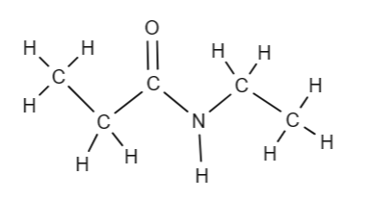

A technician needed to prepare a sample of this compound using the reagents available in the laboratory. Below is a list of what was found:

*Bromine water Ethene gas Propan-1-ol Sulfuric acid Ethanoic acid*

*Ethanol Distilled water Ammonia Potassium dichromate*

Devise a method using the materials available to prepare a sample of N-ethyl propanamide. Use chemical equations to explain each step of the process. [6 marks]

__________________________________________________________________________________

__________________________________________________________________________________

__________________________________________________________________________________

__________________________________________________________________________________

__________________________________________________________________________________

__________________________________________________________________________________

__________________________________________________________________________________

__________________________________________________________________________________

__________________________________________________________________________________

__________________________________________________________________________________

__________________________________________________________________________________

__________________________________________________________________________________

__________________________________________________________________________________

__________________________________________________________________________________

__________________________________________________________________________________

__________________________________________________________________________________

**SECTION C: EXTENDED RESPONSE SECTION (13 marks)**

**Question 16**

Nitroglycerine is an unstable, colourless, oily, liquid compound used as an explosive. It contains carbon, hydrogen, nitrogen and oxygen. A 5.000 g sample thought to be pure nitroglycerine produced 2.908 g of carbon dioxide, 0.9915 g of water and 0.924g of nitrogen gas on complete combustion.

(a) Determine the empirical formula of nitroglycerine. [11 marks]

(b) Determine the molecular formula of nitroglycerin if a sample of 0.436 moles is found to have a mass of 99.0 g. [2 marks]

**END OF TEST**